Nalongsone Danddank Student ID : 14958950 StarID: jf3893pd

Email: [nalongsone.danddank@my.metrostate.edu](mailto:nalongsone.danddank@my.metrostate.edu)\

**Metropolitan State University**

**ICS-365-01 —Organization of Programming Languages**

**Homework #4**

1. (10 points) Consider the following parse table. Parse (means show the Shift-Reduce trace, not a Parse Tree) the input “abaab” and determine if it is accepted in the grammar

1) S –> XX

2) X –> aX

3) X –> b

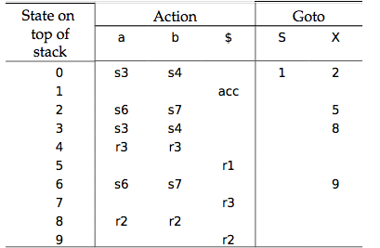

Solution:

Stack Input Action

0 abaab$ s3

0a3 baab$ s4

0a3b4 aab$ r3 [3, X]

0a3X8 aab$ r2 [0, X]

0X2 aab$ s6

0X2a6 ab$ s6

0X2a6a6 b$ s7

0X2a6a6b7 $ r3 [6, X]

0X2a6a6X9 $ r2 [6, X]

0X2a6X9 $ r2 [2, X]

0X2X5 $ r1 [0, S]

0S1 $ acc

Answer: it is **accepted** in the grammar.